Assignment 10.4

Task 1: AI-Assisted Syntax and Code Quality Review :
Task Description
You are given a Python script containing:
• Syntax errors
• Indentation issues
• Incorrect variable names
• Faulty function calls

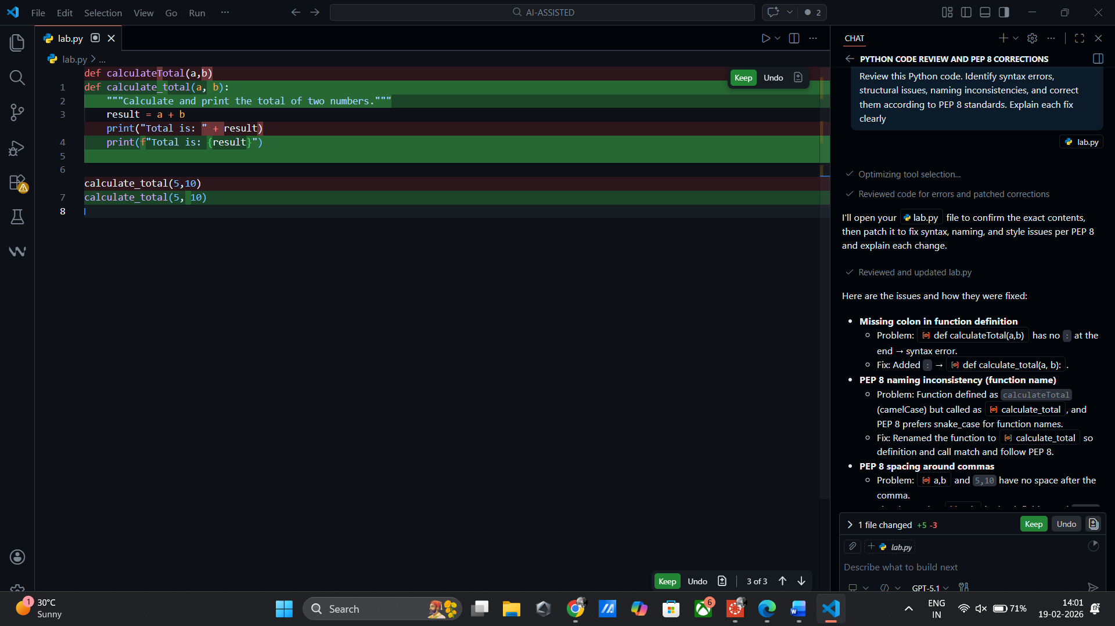

Issues Identified by AI
- Missing colon after function definition
- Function name mismatch (calculateTotal vs calculate_total)
- String concatenation with integer (TypeError)
- Naming convention not following snake_case

Task 2: Performance-Oriented Code Review

You are provided with a function that identifies duplicate values in a list
using inefficient nested loops.
Using AI-assisted code review:
• Analyze the logic for performance bottlenecks
• Refactor the code for better time complexity
• Preserve the correctness of the output
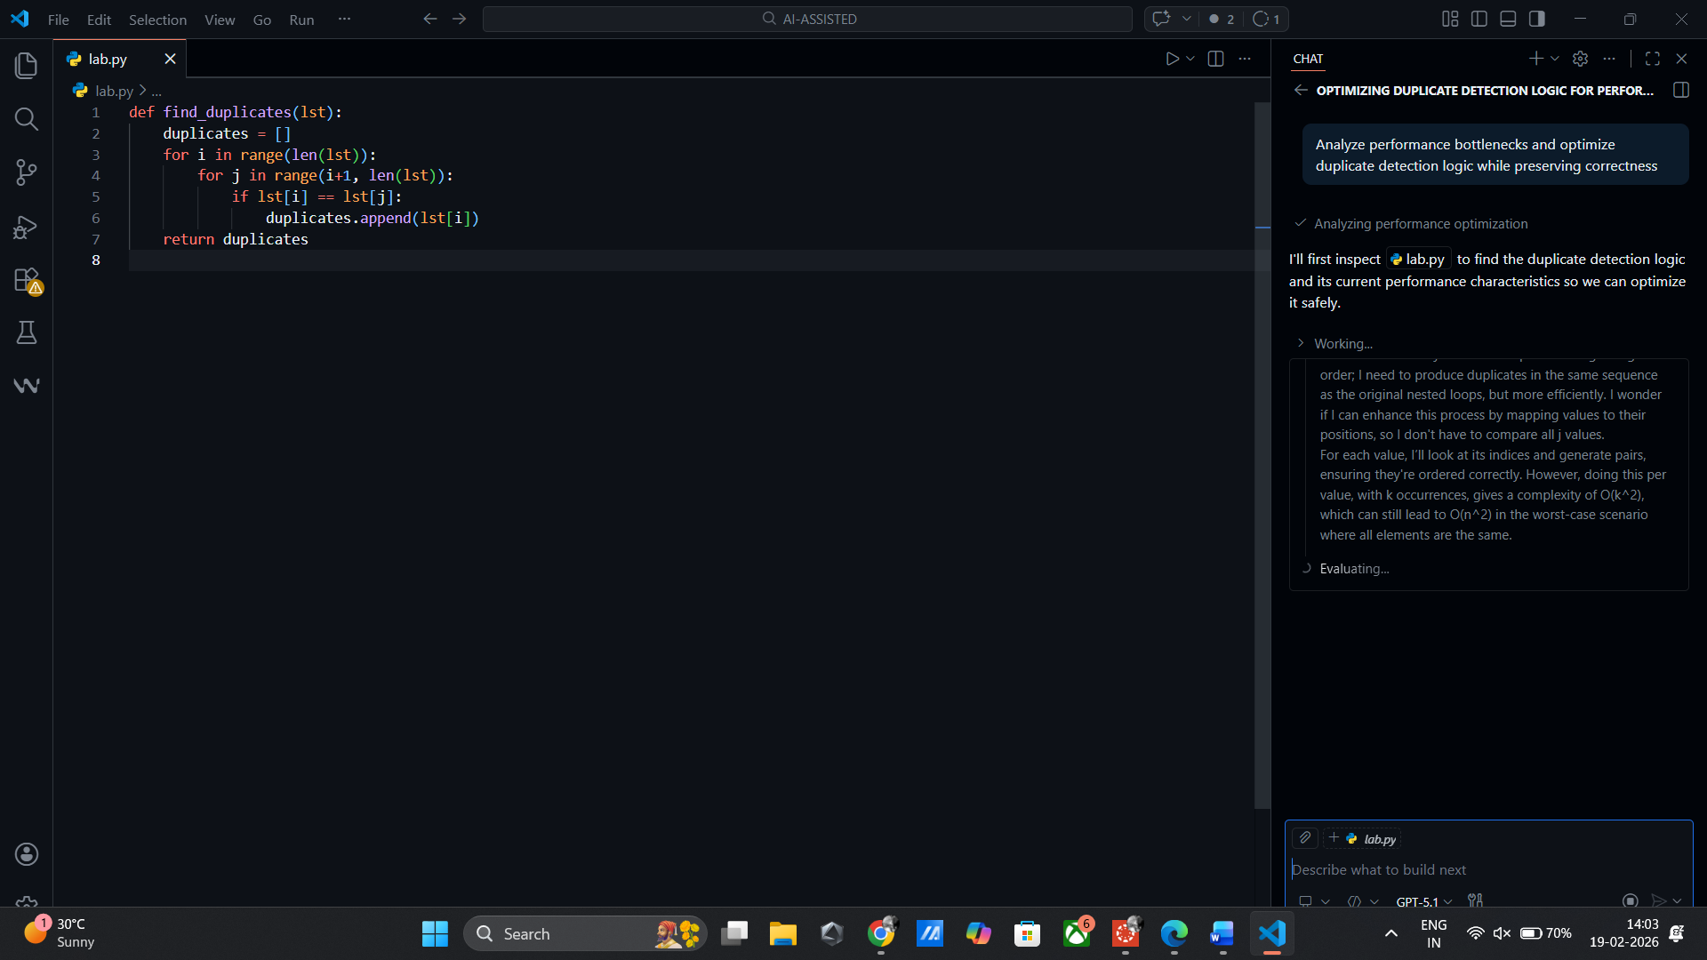

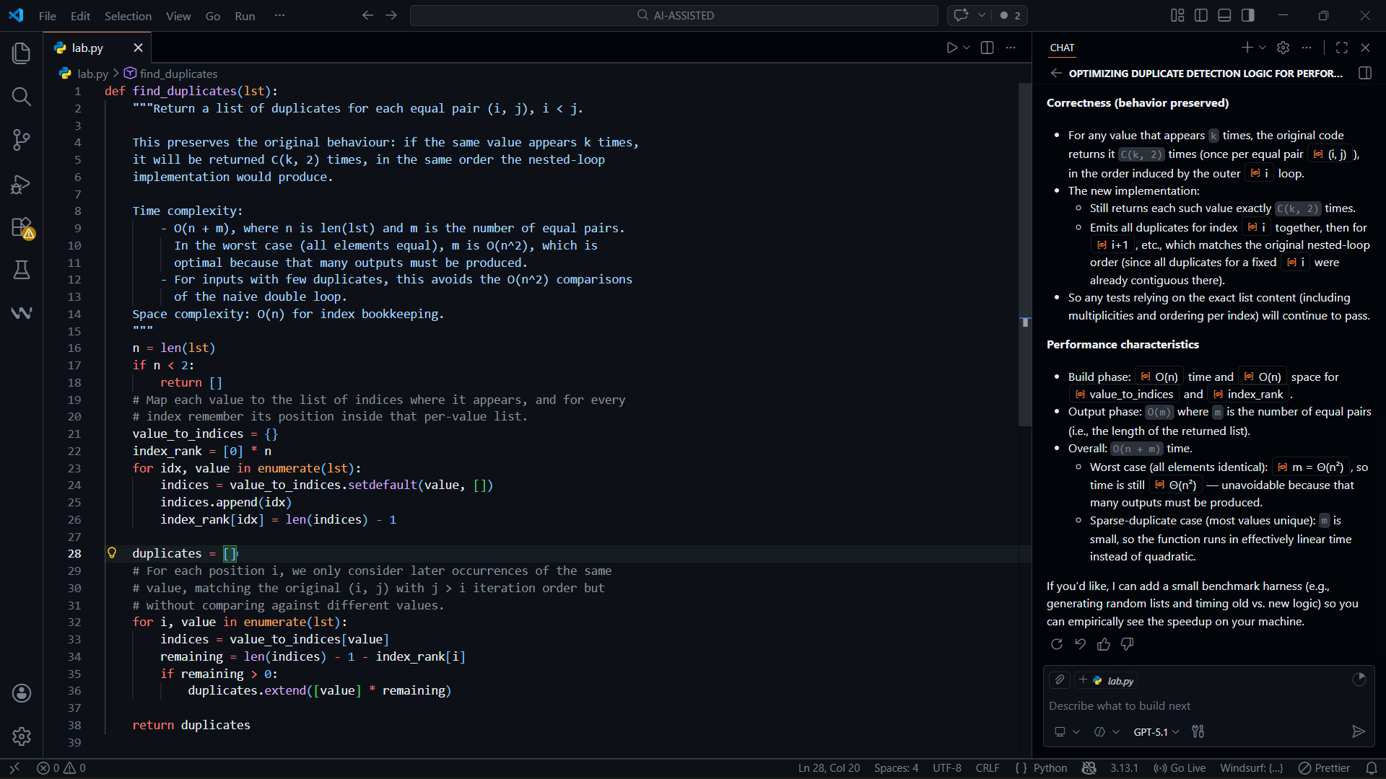
Task 3: Readability & Maintainability Refactoring
Task Description
You are given a poorly structured Python function with:
• Cryptic function names
• Poor indentation
• Unclear variable naming
• No documentation
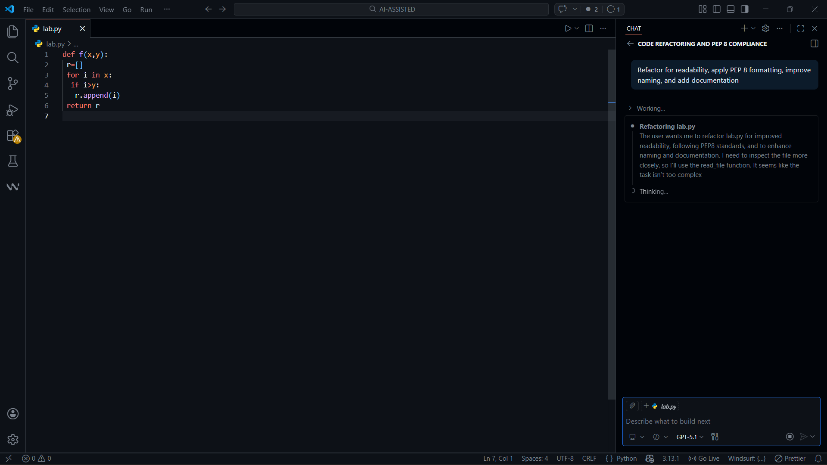
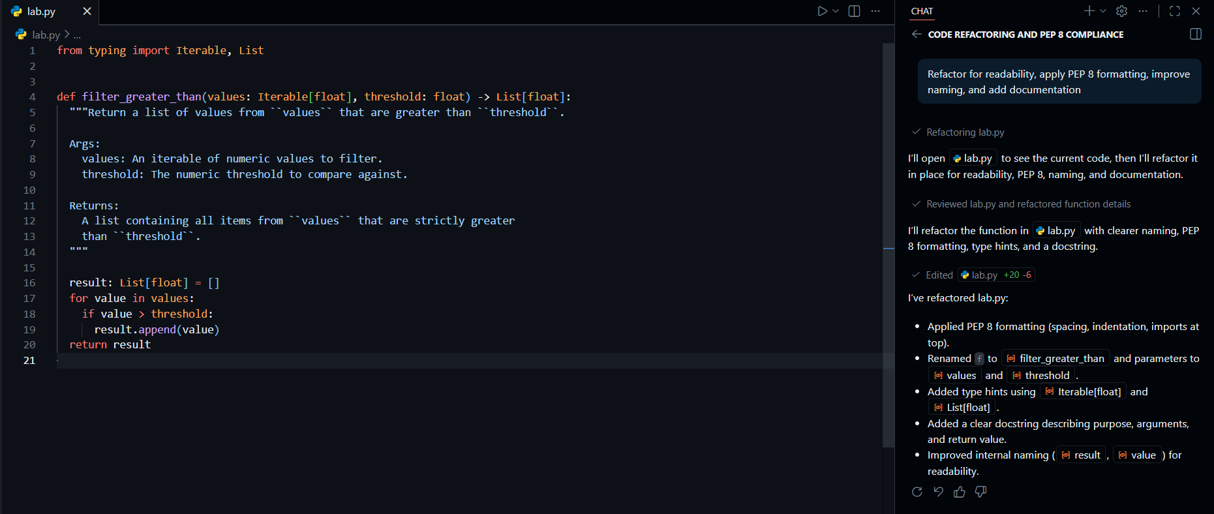

Improvements Made : Descriptive function name ,Clear variable naming, Proper indentation ,Docstring added ,Type hints included.
Task 4: Secure Coding and Reliability Review
Task Description
You are given a Python script that:
• Uses unsafe SQL query construction
• Has no input validation
• Lacks exception handling
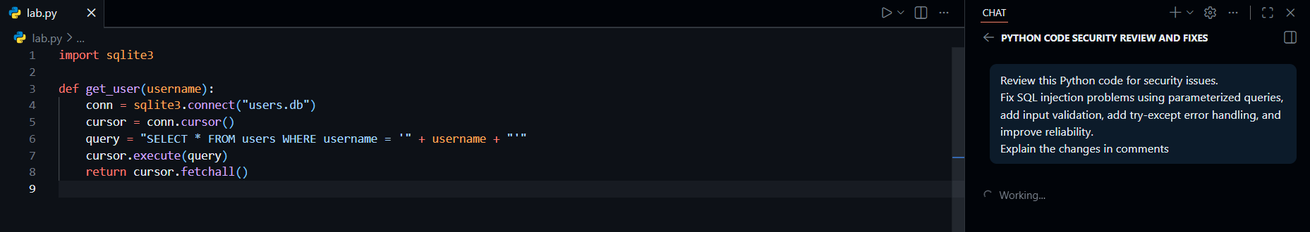
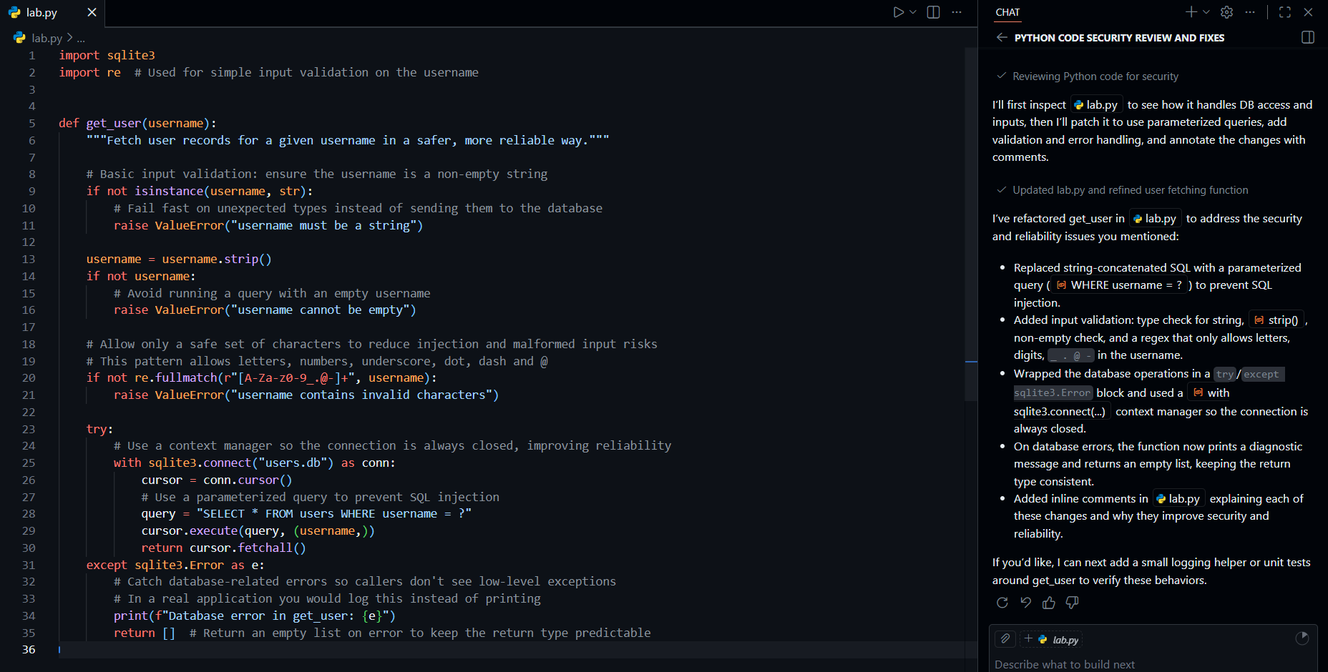

Security Improvements

Parameterized query (prevents SQL injection)
Input validation
Try-except for safety
Proper resource cleanup

Task 5: AI-Based Automated Code Review Report
Task Description
You are provided with a poorly written Python script.
Using AI-assisted review:
• Generate a structured code review report that evaluates:
Code readability
Naming conventions
Formatting and style consistency
Error handling
Documentation quality
Maintainability
The task is not just to fix the code, but to analyze and report on quality
issues
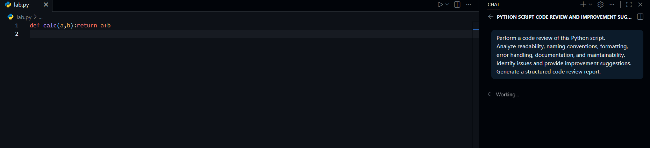
🔹 AI-Generated Code Review Report
1️⃣ Readability
- Poor formatting
- No indentation
- One-line implementation reduces clarity
2️⃣ Naming Issues
- calc is unclear
- Variables a and b not descriptive
3️⃣ Documentation
- No docstring
- No explanation of purpose
4️⃣ Maintainability Risk
- Hard to scale
- Difficult for team collaboration
Actionable Recommendations
- Rename calc to something more descriptive (e.g., add_numbers).
- Reformat the function to a multi-line definition with proper spaces around operators and after commas.
- Add a clear docstring describing purpose, parameters, and return value.
- Add type hints for parameters and return type.
- (Optional, depending on context) Add basic type validation to guard against incorrect usage.
- (Optional) If this module is to grow, add a module-level docstring and consider adding simple unit tests in a separate test fil
